JACK | MONDAY | TUESDAY | WEDNESDAY | THURSDAY | FRIDAY | SATURDAY
Brush Teeth | 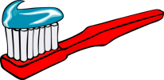
Make Bed | 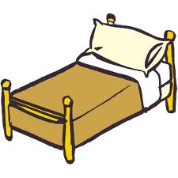
Pick Up Room | 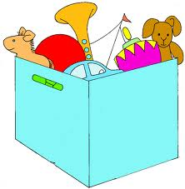
Homework | 
Feed Cat | 
Job | Empty & Fill  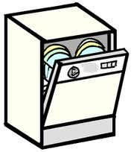 | Mudroom | Living Room   | Empty & Fill | Stairs, Stools & Entryway  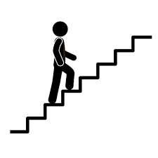 | Saturday Jobs

